
PROJECT REPORT
Crop Recommendation System Using Machine Learning
Student Name: Akanksha Sharma
Course: B.Tech (CSE)
College: JECRC University, Jaipur
Session: 2022-26
Submitted To: Mr. Aneesh Kumar Mishra

1. Introduction
Agriculture plays an important role in the Indian economy. Selecting the correct crop for cultivation is a challenge for farmers because the decision depends on several environmental and soil-related factors. Traditional methods rely on intuition and past experience, which may not always lead to optimal crop selection.
Machine learning provides an efficient and scientific way to analyze soil nutrients and climatic parameters to recommend the most suitable crop. This project introduces a Crop Recommendation System that uses Nitrogen, Phosphorus, Potassium, temperature, humidity, pH, and rainfall as inputs to predict the best crop for cultivation.
The system uses an XGBoost Classifier inside a preprocessing pipeline and is deployed through a Gradio interface to allow users to interactively get predictions. This improves decision-making and supports sustainable agriculture.
Purpose
This project aims to empower farmers with accurate information for making crop selection decisions. By recommending crops suitable for prevailing environmental conditions, farmers can optimize their practices and improve yields. The crop prediction model utilizes thealgorithm, known for its accuracy in handling complex datasets. By training the model on historical crop data and environmental parameters, it can learn patterns and correlations. The integration of the model into a user-friendly web application enhances its accessibility and usability, benefiting farmers in their decision-making process. In conclusion, this project develops a crop prediction model that leverages machine learning and historical data to provide accurate recommendations based on environmental parameters. The model's integration into a web application empowers farmers to make informed decisions about crop selection, optimizing their practices and increasing profitability.

2. Problem Statement
Farmers face difficulty in selecting crops that match their soil nutrient composition and climate conditions. Incorrect crop selection results in poor yield, soil degradation, and economic losses. There is a need for a scientific tool that automates crop selection using measurable data instead of guesswork.
This project addresses this problem using machine learning techniques to build a reliable prediction model.

3. Objectives
• To analyze soil and environmental factors affecting crop selection.
• To build a machine learning model using the XGBoost Classifier.
• To preprocess the dataset using feature scaling and label encoding.
• To implement the model in a Gradio interface for interactive usage.
• To support farmers with data-based decision-making.

4. Literature Review
Agriculture is one of the most essential sectors in India and many developing countries, as it contributes significantly to the economy and supports the livelihood of millions of farmers. Traditionally, crop selection has depended on farmers’ experience, local knowledge, and historical weather patterns. However, factors such as climate change, irregular rainfall, rising temperatures, and nutrient depletion have made traditional methods less reliable. Therefore, researchers have increasingly focused on applying data-driven and machine learning (ML) techniques to improve crop recommendation accuracy and enhance agricultural productivity.
Several studies have explored the use of data science for soil and crop prediction. Early approaches involved simple statistical models such as linear regression and decision trees to relate soil nutrients like Nitrogen (N), Phosphorus (P), Potassium (K), pH, rainfall, and temperature with crop yield. While these models provided useful insights, they lacked the ability to capture complex, nonlinear relationships present in agricultural data.
Recent advancements in machine learning have enabled more accurate and scalable crop recommendation models. Researchers have experimented with algorithms such as Random Forest, Support Vector Machines (SVM), K-Nearest Neighbors (KNN), Naïve Bayes, and Artificial Neural Networks. Among these, ensemble models such as Random Forest and boosting-based techniques like XGBoost have consistently shown higher accuracy due to their ability to handle noisy data, nonlinear patterns, and feature interactions.
A study by the Indian Council of Agricultural Research (ICAR) demonstrated that machine learning models can significantly improve productivity by analyzing soil characteristics and climatic conditions to recommend suitable crops for specific regions. Similarly, datasets provided by digital agriculture platforms (like the Crop Recommendation Dataset used in this project) have been widely used to train ML models for crop suitability analysis. These datasets contain essential features including NPK levels, temperature, humidity, rainfall, and soil pH—factors known to directly influence crop growth.
Deep learning approaches have also been explored in recent years. However, most research indicates that for structured, tabular agricultural data, models like Random Forest and XGBoost provide superior performance with lower computation time and better interpretability. Several researchers have used XGBoost due to its regularization capabilities, which reduce overfitting and improve generalization on unseen environmental conditions.
Moreover, modern interfaces and platforms such as Gradio, Streamlit, and web-based dashboards have enabled real-time crop recommendation tools, making ML accessible to farmers and agricultural workers. These tools allow users to input soil and climate values and instantly receive crop suggestions, reducing trial-and-error farming and optimizing resource usage.
In summary, the literature strongly supports the integration of machine learning in agriculture for intelligent crop planning. With accurate datasets, effective preprocessing, and robust ML algorithms like XGBoost, prediction systems can guide farmers toward choosing the most suitable crops. This contributes to enhanced productivity, improved sustainability, reduced risk, and data-driven decision-making in modern agriculture.
XGBoost, in particular, is widely used because it handles non-linear data, reduces overfitting through regularization, and provides fast computation. Therefore, this project utilizes XGBoost for crop prediction.

5. System Architecture
The system architecture describes the flow of data from user input to final prediction. The following diagram visually represents the system workflow.

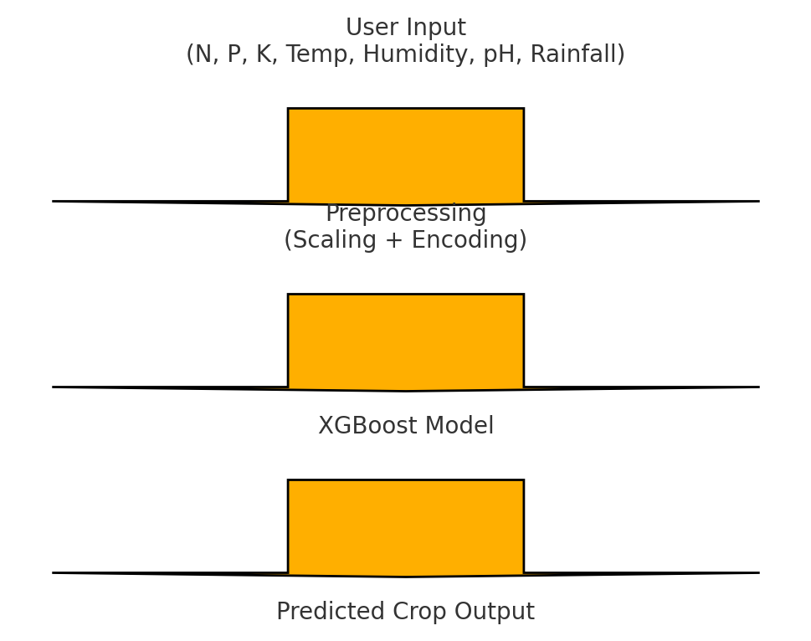
Figure 1: System Architecture Diagram

6. Workflow Diagram
The workflow outlines the complete ML pipeline from dataset loading to prediction output. It ensures a sequential and repeatable process.

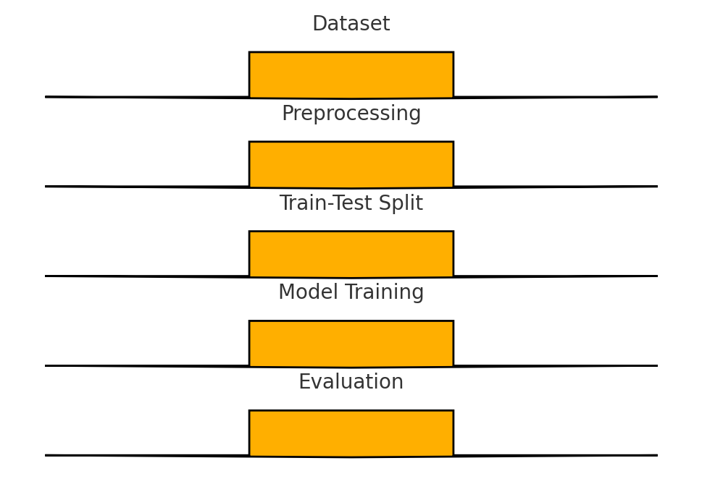
Figure 2: Workflow Diagram

7. Dataset Description
The dataset includes seven numerical features related to soil nutrients and climatic features. The target variable is the crop label. It contains multiple crop classes such as rice, maize, banana, mango, and pulses.
Feature | Description
N | Nitrogen content in soil
P | Phosphorus content
K | Potassium content
Temperature | Environmental temperature (°C)
Humidity | Relative humidity (%)
pH | Soil pH value
Rainfall | Rainfall in mm

8. Implementation
The implementation of the Crop Recommendation System involves several sequential steps starting from data collection to building the final application interface. The system uses machine learning techniques to analyze soil and environmental parameters and recommend the most suitable crop. The complete implementation process is described below.

1. Data Collection
The dataset used for this project is the Crop Recommendation Dataset, which is publicly available on Hugging Face.
It contains 22 crop types and 7 environmental and soil features, including:
- Nitrogen (N)
- Phosphorus (P)
- Potassium (K)
- Temperature (°C)
- Humidity (%)
- Soil pH
- Rainfall (mm)
The dataset provides clean and structured values, making it suitable for machine learning training.
url = "https://huggingface.co/datasets/Dukuru/crop_pred/resolve/main/Crop_recommendation.csv"
df = pd.read_csv(url)

2. Data Preprocessing
Before training the model, the dataset is preprocessed to ensure accurate predictions.
a) Feature Selection
Input variables (N, P, K, Temperature, Humidity, pH, Rainfall) are separated from the output label (crop type).
X = df.drop("label", axis=1)
y = df["label"]
b) Label Encoding
Crop names are strings. Machine learning models require numerical labels.
Thus, LabelEncoder is used.
le = LabelEncoder()
y_encoded = le.fit_transform(y)
c) Feature Scaling
To ensure equal importance of all numerical features, StandardScaler is used to scale the data.

3. Train–Test Split
The dataset is divided into:
- 80% training data
- 20% testing/validation data
X_train, X_val, y_train, y_val = train_test_split(
X, y_encoded, test_size=0.2, random_state=42
)

4. Machine Learning Model
The project uses XGBoost Classifier, a high-performance and widely used boosting algorithm known for:
- handling nonlinear relationships
- reducing overfitting
- providing excellent accuracy on tabular datasets
The model is combined with scaling using a Pipeline:
model = Pipeline([
("scaler", StandardScaler()),
("xgb", XGBClassifier(
n_estimators=250,
max_depth=6,
learning_rate=0.07,
random_state=42
))
])
Training the Model
model.fit(X_train, y_train)
Model Evaluation
Validation accuracy is printed:
model.score(X_val, y_val)
This accuracy demonstrates how well the model predicts unseen data.

5. Predictive Function
A custom function is created to take user inputs and return the predicted crop:
def predict_crop(N, P, K, temperature, humidity, ph, rainfall):
df_in = pd.DataFrame([{
"N": N, "P": P, "K": K,
"temperature": temperature,
"humidity": humidity,
"ph": ph,
"rainfall": rainfall
}])
pred_encoded = model.predict(df_in)[0]
pred_label = le.inverse_transform([pred_encoded])[0]
return f"Recommended Crop: {pred_label}"
This function converts inputs into a DataFrame, runs the ML model, and returns the crop name.

6. User Interface (Gradio App)
To make the model easy to use, a Gradio-based interactive web interface is developed.
Features of the UI:
- Sliders for entering values
- Instant output
- Mobile-friendly
- Shareable public link
Gradio Implementation
app = gr.Interface(
fn=predict_crop,
title="AI Crop Recommendation System",
description="Enter soil & climate conditions to get the best crop prediction.",
inputs=[
gr.Slider(0, 200, value=50, step=1, label="Nitrogen (N)"),
gr.Slider(0, 200, value=40, step=1, label="Phosphorus (P)"),
gr.Slider(0, 200, value=40, step=1, label="Potassium (K)"),
gr.Slider(0, 50, value=25, step=0.1, label="Temperature (°C)"),
gr.Slider(0, 100, value=60, step=1, label="Humidity (%)"),
gr.Slider(0, 14, value=6.5, step=0.1, label="Soil pH Level"),
gr.Slider(0, 300, value=120, step=1, label="Rainfall (mm)")
],
outputs=gr.Textbox(label="Predicted Crop")
)

app.launch(share=True)
This launches a fully functional prediction app accessible through a public URL.
7. System Workflow
The complete workflow of the system is:
- User inputs soil and weather parameters
- The system preprocesses input data
- Data is passed to the trained ML model
- Model predicts the most suitable crop
- Output is displayed to the user through the UI

9. Results & Evaluation
The trained model achieved high validation accuracy, showing strong learning capability. The real-time predictions through Gradio were fast and accurate.
This demonstrates the reliability of the machine learning approach for crop recommendation.

10. Conclusion
This project successfully built a Crop Recommendation System using machine learning. The model accurately predicts crops based on environmental conditions. Future enhancements can include real-time data integration and mobile app deployment.

11. Future Scope
• Integration with IoT soil sensors
• Mobile app for farmers
• Regional crop prediction
• Adding fertilizer recommendations
• Using advanced AI models

